Name:

ID:

M2 Assignment C1-03 V1

Part 1:

1. Create the following using HTML, CSS, and JavaScript. When you hover over each element in the periodic table, the background color should change to yellow:

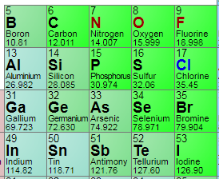

1. Create the following using HTML, CSS, and JavaScript. When you click on the orange ellipse it should change color from orange to pink:

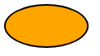

1. Create the following with HTML, CSS, and JavaScript. When you click on the ellipse it should go completely black for 1 second, and then go back to normal:

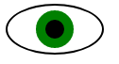

1. Use HTML, CSS, and Javascript to create the following. Whatever the user types in the text input box should be displayed in an h2 element above the text-input:

Before:



After:

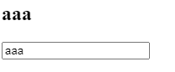

1. Recreate the following using HTML, CSS, and Javascript. The websites should be hyperlinks (HTML <a> tags) that lead to a website. The images can be anything that you find interesting (school appropriate).

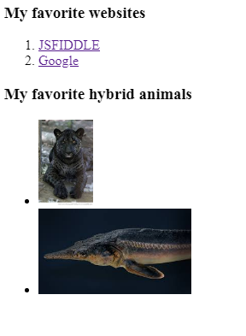

Part 2:

1. Which of the following HTML tags is a web page within a webpage:

|  |  |
| --- | --- |
| audio | webpage |
| iframe | internet |
| frame | Editor |
| browser | javascript |

1. Which of the following makes comments for HTML and CSS:

|  |  |
| --- | --- |
| HTML: <!-- ->  CSS: /**/ | HTML: <!-- ->  CSS: // |
| HTML: <--- ->  CSS: /**/ | HTML: //  CSS: // |
| HTML: /**/  CSS: // | HTML: “”  CSS: /**/ |
| HTML: {}  CSS: () | HTML: <!-- 🡪  CSS: “” |

1. Which of the following is not an HTML input type:

|  |  |
| --- | --- |
| text | email |
| password | date |
| checkbox | tel |
| file | id |

1. Which of the following generates an error:

|  |  |
| --- | --- |
| const PI = 3.141592653589793;  PI = 3.14; | let PI = 3.141592653589793;  PI = 3.14; |
| var PI = 3.141592653589793;  PI = 3.14; | const PI = 3.141592653589793; |
| let PI = 3.141592653589793; | var PI = 3.141592653589793; |

1. Which of the following generates a date in javascript:

|  |  |
| --- | --- |
| Today() | Newdate() |
| new Date() | new Day() |
| Day() | the Date() |
| date() | genDate() |